# **An Introduction to Mongo DB & CRUD (CREATE, READ, UPDATE, RETRIEVE, DELETE) Manipulations**

We will divide the blog in to the below categories

* What and why mongo DB
* Installation and testing of mongo environment in windows platform
* CRUD operation using Mongo DB
* Test and import for JSON file in to mongo DB

# What and Why Mongo DB

Mongo DB is open source document database and NO SQL database

Below are the set of advantages which we can compare between MONGO DB over RDBMS

## Mongo DB Versus RDBMS

* Mongo DB is schema less where one collection holds different documents(Records/Rows)
* No Complex Joins
* Mongo supports deep query ability that is documents inside the collections are queried through document query language which is as powerful comparing SQL
* Mongo DB is easy to scale
* No mapping is required in Mongo DB everything is done by itself

## Why Mongo DB?

1. Information is stored together for fast query access through the MongoDB query language.
2. MongoDB uses dynamic schemas, meaning that you can create records without first defining the structure, such as the fields or the types of their values.
3. You can change the structure of records (which we call documents) simply by adding new fields or deleting existing ones.
4. This data model give you the ability to represent hierarchical relationships, to store arrays, and other more complex structures easily.
5. Documents in a collection need not have an identical set of fields and denormalization of data is common.
6. Includes out-of-the-box replication and auto-sharding

# Installation and testing of mongo environment in windows platform

Follow the below step one by one

The following are the steps to install the MongoDB on windows:

**Step1:** Download the latest version of mongo DB

Bottom of Form

Make sure you get correct version of MongoDB depending upon your windows version. (Choose legacy)

For 64 bit, use this link to download -> [https://www.mongodb.org/downloads](https://www.mongodb.org/downloads%20)

**Step2:** Extract the zip file.

Step3: Set up the mongo DB environment

* Crate the folder name as mongodb within the following path C:\mongodb
* Have the list of four folders along with the one of the property file as shown in the below screen shot

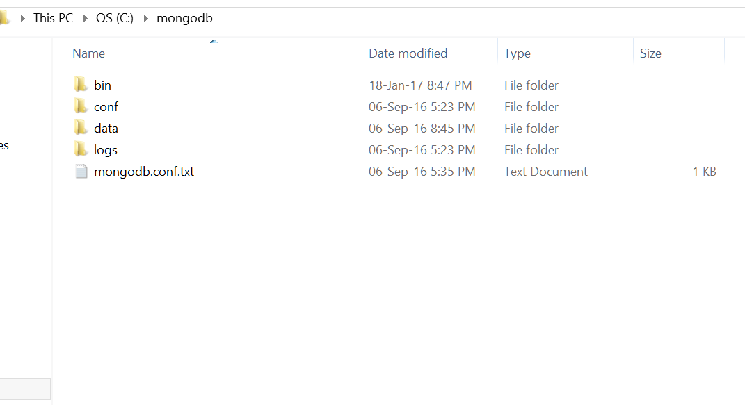

* bin folder contains all your mongo executable files
* conf file is just the configuration file
* data folder we use it for storing data purposes
* Create one more folder called as db inside it
* logs folder is used for checking mongo related errors

Paste the following in mongodb.conf.txt

# mongodb.conf

# Data

dbpath=c:\mongodb\data\db

# Log

logpath=c:\mongodb\logs\mongodb.log

logappend=true

# Only run on localhost for development

bind_ip=127.0.0.1

# Default MongoDB port

port=27017

Save the file after copy paste.

All done with the installation.

Let us test the mongo environment.

Open command prompt from the following directory

C:\mongodb\bin

* Type mongod.exe

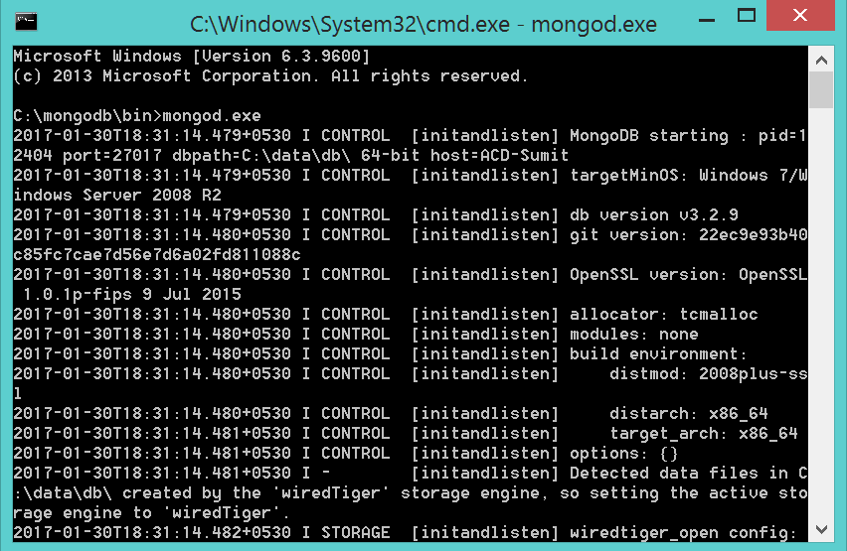

Also check with the below command also to ensure successful installation

Open one more command prompt from the same path “C:\mongodb\bin”

Type mongo.exe

As we type this command it shows the below screen shot.

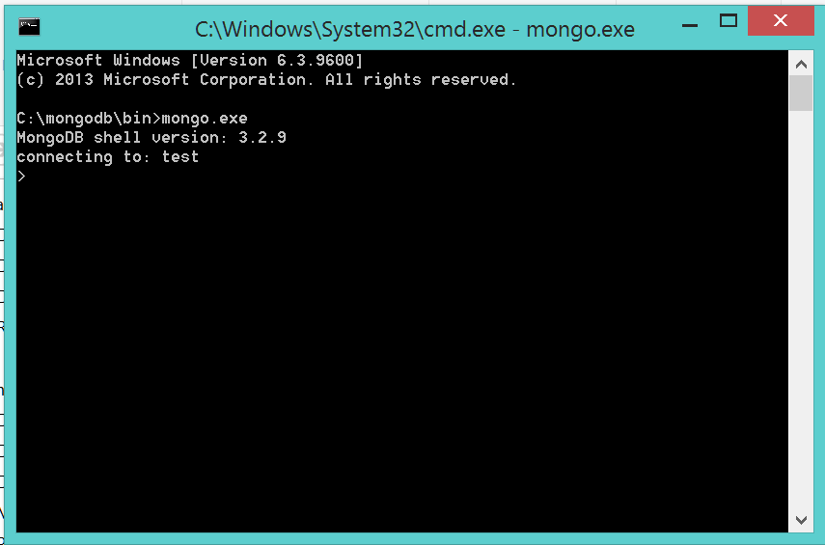

All set readers!!!!!!!!!!! we are done with the mongo db installation and testing

# CRUD OPERTIONS USING MONGO DB

Follow the below steps one by one

Step 1: create the database by typing the below command

use Users

Look at the below screen shot

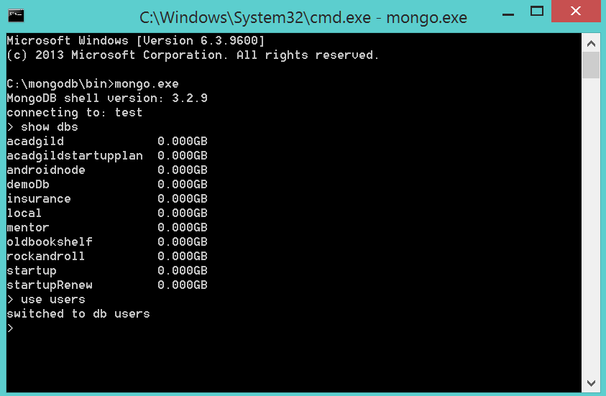

Step 02: Create the collections (i.e., Tables in sql)

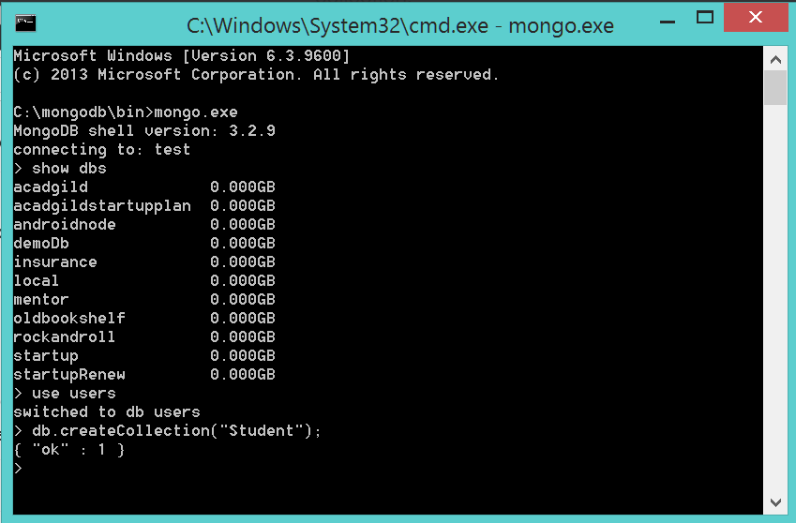

Step 03: Insert some records using the below command

db.Students.insert(

{ item: "notebook", qty: 50, tags: ["red", "hard cover", "plain"], size: { h: 8.5, w: 11, uom: "in" } }

)

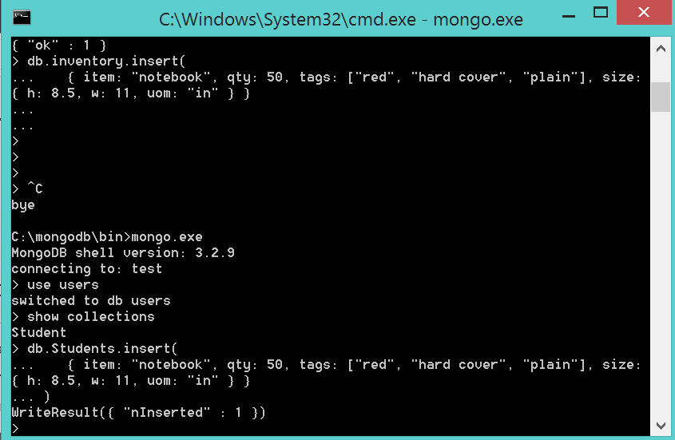

Step 4: View the inserted records using the below command

Db.Students.find()

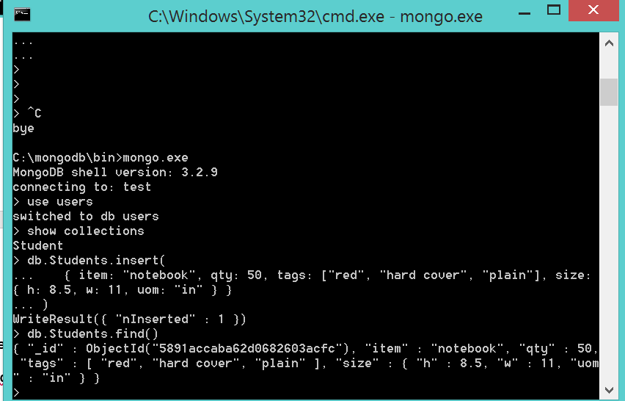

## New commands in the mongo version 3.2

db.collection.insertOne()